Using DOORS Next to manage acceptance criteria for Engineering

Workflow Management work items

Todd Dunnavant, PhD, PE, SPC
IBM Technology Sales

May 3, 2019, updated April 23, 2021
Introduction
In this document, we present an approach for using DOORS Next as the tool for creating, authoring, and managing acceptance criteria (ACs) associated with Engineering Workflow Management (formerly Rational Team Concert) work items.
Document organization
- Motivation for the approach
- What is needed
- Approach description
- Implementation details
Motivation for the approach
- Many Agile teams appear to be equating work item ACs with requirements.
- In the IBM Engineering Lifecycle Management (ELM) tools, ACs by default are treated as integral parts of a specific work item. All ACs for a given work item are collectively authored in a single rich text format edit control. This field has limited formatting capability.
- Creating and authoring comprehensive ACs, using a structured behavior description language such as Gherkin, is becoming popular. Such ACs can be quite complex, for example including descriptions of multiple scenarios and including data tables.
The following issues arise from the above three items:
- Teams largely lose the ability to manage their requirements as long-lived lifecycle artifacts. Once a work item (and its included ACs) is closed, it largely because a thing of the past.
- Teams lose the ability to reuse ACs effectively. “Reusing” an AC becomes an exercise in copying and pasting AC text between work items. Coordinating changes between the different usages of an AC is difficult and prone to error.
- Teams largely lose the ability to report on requirements individually. All the ACs for a given work item are documented in a single work item field. In order to report these individually, special processing would be required to parse the work item AC field. Further, the content of the AC field would need to be consistently authored using a syntax that is understood by the parsing tool.
- The ability to establish traceability that includes work items, related requirements, and validating test cases is impaired. Traceability is reduced to work items and their linked test cases.
- As a result of Item 4, the ability to report on the verification status of individual ACs is impaired.
- Substantial aspects of ELM automation no longer are available. For example:
a. The ability to auto-create test cases from to-be-verified artifacts, and auto-link the test cases with these artifacts, is eliminated. ELM supports auto-creating test cases from, and auto-linking them to, DOORS Next artifacts. ELM doesn’t support similar operations using work items as the source.
- Finally – for teams that wish to author comprehensive ACs, and have multiple ACs per work item, doing this using the single AC editing control that an RTC work item provides is a challenge.
What is needed
A solution to the above issues needs to have the following characteristics:
- Provide ACs as long-lived artifacts that can survive the closure of an associated work item
- Provide ACs that can be reused across multiple work items
- Provide ACs that can be reported effectively
- Provide ACs that facilitate testing at the level of the AC
- Provide ACs that facilitate ELM tool automation
- Provide robust AC editing capabilities
Approach description
Briefly, our approach involves creating and authoring ACs using DOORS Next. ACs become independent ELM artifacts. The following results are achieved:
- An AC’s lifetime is independent of the lifetime of any work item
- An AC can be associated with multiple work items
- An AC can be reported as a separate lifecycle artifact. For example, a Report Builder report can be created that shows work items related to ACs related to test cases related to test case results.
- Engineering Test Management (ETM) automations that auto-create and auto-link test cases from and to DOORS Next artifacts become available
- An AC can be edited using the robust DOORS Next rich text editor
To implement the solution, we do the following:
- Provide a new text-format DOORS Next artifact type – Acceptance Criterion
- Add a link widget to the Acceptance Criteria tab or Success Criteria tab of EWM planning work item types, such as Story, Feature, and Program Epic
Figures 1 and 2 illustrate (1) how the implementation appears in an EWM Story and (2) the process for creating and editing ACs.

Figure 1. AC implementation as seen in EWM
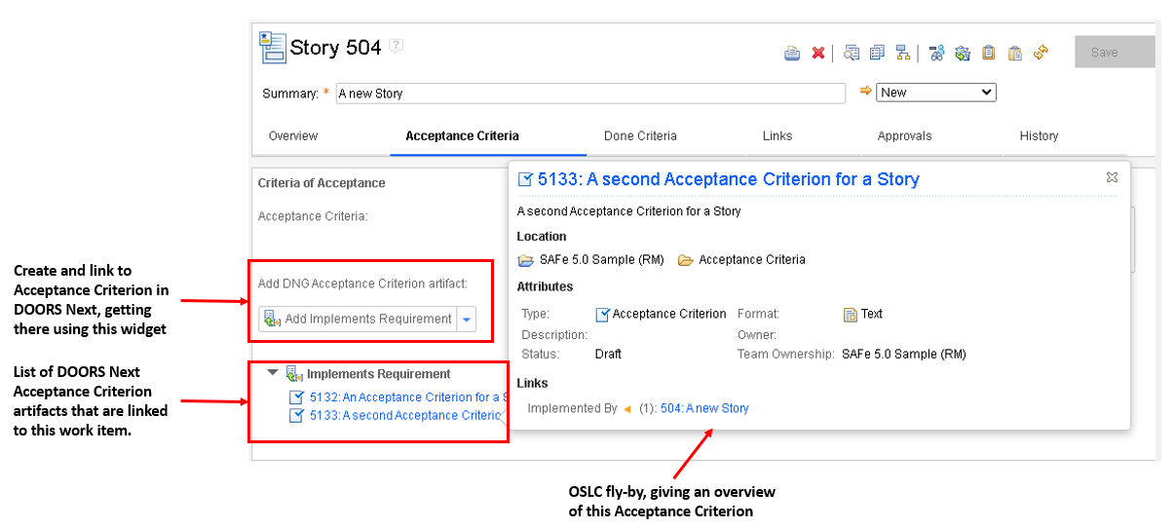
Figure 2. Process for creating and editing ACs
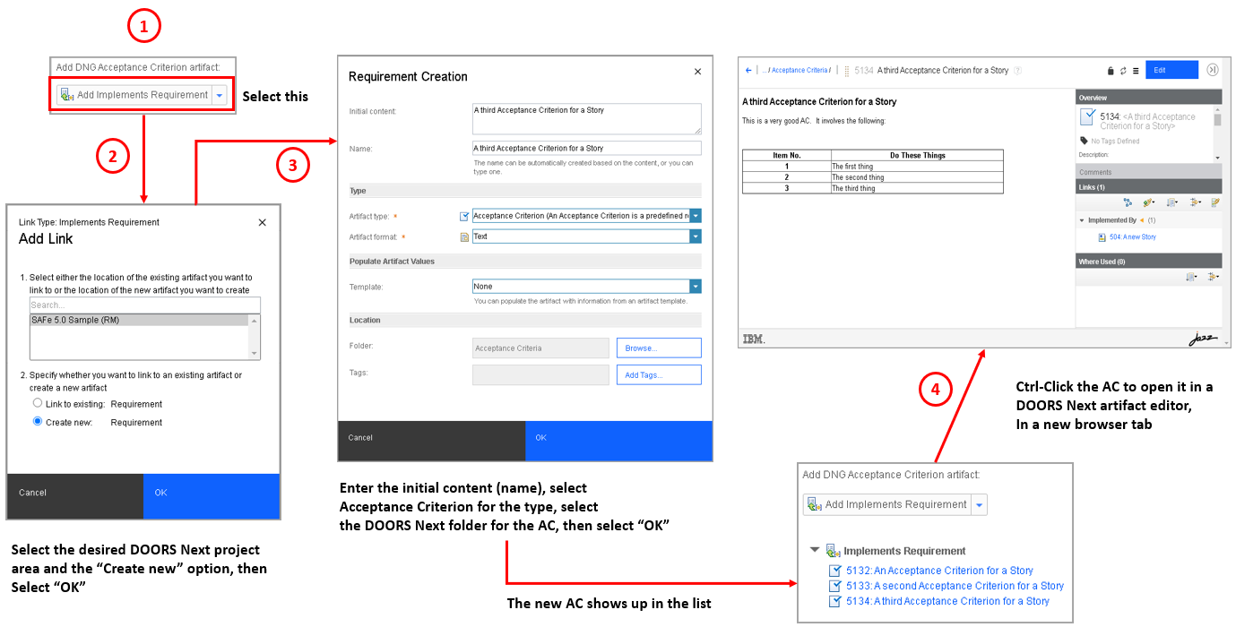

Implementation Details
Create the DOORS Next Acceptance Criterion artifact type
Create the Acceptance Criterion as a new text-formatted artifact type.
See this IBM Documentation page for guidance regarding how to do this:
https://www.ibm.com/docs/en/elm/7.0.2?topic=properties-creating-artifact-types
Add the “Add Acceptance Criterion Artifact” presentation to work items
The procedure is described below, using EWM Scaled Agile Framework (SAFeTM) project areas and a SAFe Feature work item type as an example.
We recommend that the changes be made in one or more “master” EWM project areas, each of which shares its process definition with other “dependent” EWM project areas. Once the changes are implemented in a “master” project area, they automatically will be shared with its “dependent” project areas.
Pre-requisite
Identify the work item editor presentations that need to be augmented. For example, the following table lists the editor presentations that need to be augmented for various SAFe work item types, for project areas that conform to two of EWM’s SAFe configurations.
SAFe configuration | Work item type | Work Item editor to be augmented
Essential SAFe 5.0 | Story | com.ibm.team.apt.editor.story
Essential SAFe 5.0 | Feature | com.ibm.team.editor.feature
Essential SAFe 5.0 | Program Epic | com.ibm.team.editor.programEpic
Full SAFe 5.0 | Capability | com.ibm.team.editor.capability
Full SAFe 5.0 | Solution Epic | com.ibm.team.editor.valueStreamEpic
Full SAFe 5.0 | Portfolio Epic | com.ibm.team.editor.portfolioEpic

Procedure steps
1. Navigate to the project area administration UI of the “master” project area
2. Select the Work Items link on the left side of the administration UI, then select Editor Presentations
3. Select an editor to be augmented (see the list from the above table).
4. Navigate to the pertinent section of the editor
- For the Story, Feature, and Capability editors, select the link for the Acceptance Criteria section.
- For all Epic editors, select the link for the Success Criteria section
5. Select the green “+” icon for the Criteria of Acceptance editor sub-section

Figure 3. Sample work item presentation to be augmented
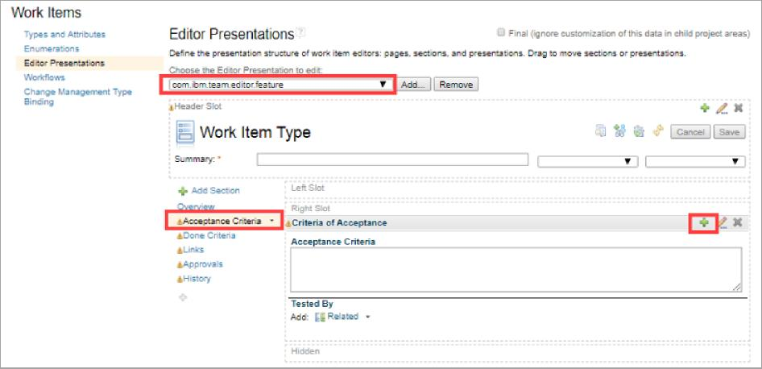
- In the resulting Edit Presentation dialog, provide the information indicated below. Add properties by selecting the Add link on the dialog.
a. The value for the linkTypeFilter property is [com.ibm.team.workitem.linktype.implementsRequirement]. Be certain to include the brackets!
- Once you’ve completed the dialog, select OK.
Figure 4. Edit Presentation dialog for the new linker widget
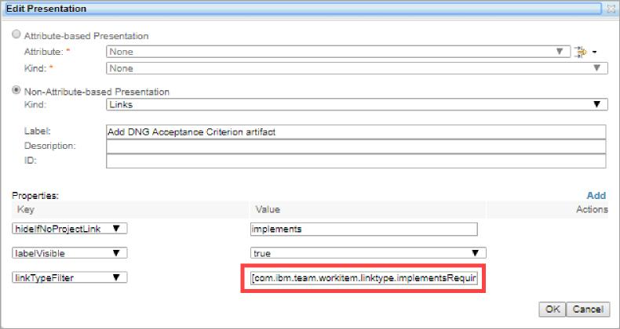
The result in the editor should be as follows.

Figure 5. Work item presentation augmented with linker widget for DOORS Next ACs
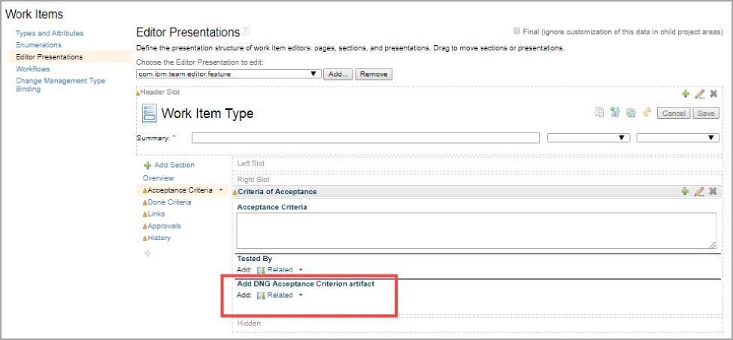
- Save your work, then make similar changes to the other editors.
- Be certain to test out your work, for each of the work item types for which the linker is being implemented!
What is shown here is a Feature which has been augmented by the new linker. In this case, we also had implemented the DOORS Next Acceptance Criterion in the DOORS Next project area that was associated to the subject EMW project area. We exercised the linker twice, to create new DOORS Next-based acceptance criteria. The links for the new ACs appear below the linker.
